Design failures of the Eurozone
Paul De Grauwe 07 September 2015
Economists were early critics of the design of the Eurozone, though many of their warnings went unheeded. This column discusses some fundamental design flaws, and how they have contributed to recent crises. National booms and busts lead to large external imbalances, and without individual lenders of last resort – national central banks – these cycles lead some members to experience liquidity crises that degenerated into solvency crises. One credible solution to these design failures is the formation of a political union, however member states are unlikely to find this appealing.
104
a
A

Related
- A consistent trinity for the Eurozone
Marco Buti
- Hume on hold? Consequences of not abolishing Eurozone national central banks
Michael Burda
- Eurozone design and management failures
Guillermo de la Dehesa
- The Eurozone needs a political union, or at least elements of one
Paul De Grauwe
The Greek crisis exposes the design failures of the Eurozone. These have long been known. Right from the start of the Eurozone many economists warned that these design failures would lead to problems and conflicts within the currency union, and that the Eurozone in the end would fall apart if these failures were not corrected. See, for instance, Feldstein (1997), Friedman (1997), or De Grauwe (1998).1
The first signs of the disintegration of the Eurozone are visible today. Grexit is temporarily avoided. The new punitive program that is imposed on Greece is likely to lead to a Grexit. But that is unlikely to be the end. After Grexit the nature of the Eurozone will have been changed from a permanent union to a temporary one. This is likely to destabilise the monetary union each time a recession produces rising budget deficits and debt levels. After Grexit there are likely to be more exits; an unravelling of the union.
‘Visionary’ European politicians brushed aside the warnings from economists in the 1990s that the euro was based on a flawed construction. Nothing would stop their great monetary dream, certainly not the objections of down-to-earth economists. What are these design failures?

The Eurozone is not an optimal currency area
The European monetary union lacked a mechanism that could stop divergent economic developments between countries. Some countries experienced a boom, others a recession. Some countries improved their competitiveness, others experience a worsening. These divergent developments led to large imbalances, which were crystallised in the fact that some countries built up external deficits and other external surpluses.
When these imbalances had to be redressed, it appeared that the mechanisms to redress the imbalances in the Eurozone (‘internal devaluations’) were very costly in terms of growth and employment, leading to social and political upheavals. Countries that have their own currency and that are faced with such imbalances can devalue or revalue their currencies.
In a monetary union, countries facing external deficits are forced into intense expenditure reducing policies that inevitably lead to rising unemployment. This problem was recognised by the economists that pioneered the theory of optimal currency areas (Mundell 1961, McKinnon 1963, Kenen 1969; along with later important contributions, including Bayoumi and Eichengreen 1993, Krugman 1993).
- The standard response – based on the theory of optimal currency area thinking – is monetary union members should do structural reforms so as to make their labour and product markets more flexible.
By increasing flexibility through structural reforms the costs of adjustments to asymmetric shocks can be reduced and the Eurozone can become an optimal currency area. This has been a very influential idea and has led Eurozone countries into programs of structural reforms.
It is often forgotten that although the theoretical arguments in favour of flexibility are strong, the fine print of flexibility is often harsh. It implies wage cuts, fewer unemployment benefits, lower minimum wages, and easier firing. Many people hit by structural reforms resist and turn to parties that promise another way to deal with the problem, including an exit from the Eurozone.
- From an economic point of view, flexibility is the solution; from a social and political point of view, flexibility is the problem.
There is a way to reduce the costs of the adjustment to imbalances in a monetary union if this adjustment can be made to operate symmetrically. Thus, if the inevitable austerity by the deficit countries can be compensated by fiscal stimulus in the surplus countries, the negative aggregate demand effects in the former can be compensated by positive demand effects in the latter (see Wolf 2014).
Such a symmetric adjustment mechanism did not operate in the Eurozone after 2010, when the large external imbalances in the Eurozone were exposed. The deficit counties were forced into austerity while the surplus countries tried to balance their budgets. The result has been to create a deflationary bias in the Eurozone.
This is illustrated in Figures 1 and 2.
- Figure 1 compares the evolution of real GDP in the Eurozone with real GDP in the US and in the EU-countries not belonging to the Eurozone (EU10).
The difference is striking. Prior to the financial crisis, the Eurozone real GDP was on a slower growth path than in the US and EU10. Since the financial crisis of 2008 the divergence has increased even further. Real GDP in the Eurozone stagnated and in 2014 was even lower than in 2008. In the US and EU10, one observes (after the dip of 2009) a relatively strong recovery.
- Figure 2 shows the evolution of unemployment in the same group of countries.
We observe the same phenomenon. A recovery in the US and EU10 after 2010, evinced by the decline in unemployment. This contrasts with the Eurozone where unemployment continued to increase so that in 2014 it was almost twice as high than in EU10.
Figure 1. Real GDP in Eurozone, EU10, and US (prices of 2010)
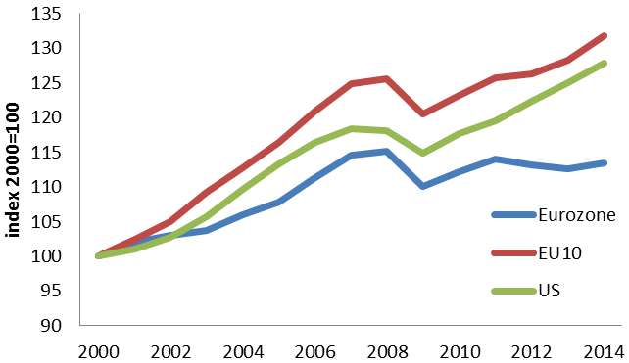
Figure 2. Unemployment rate in Eurozone, EU10, and US
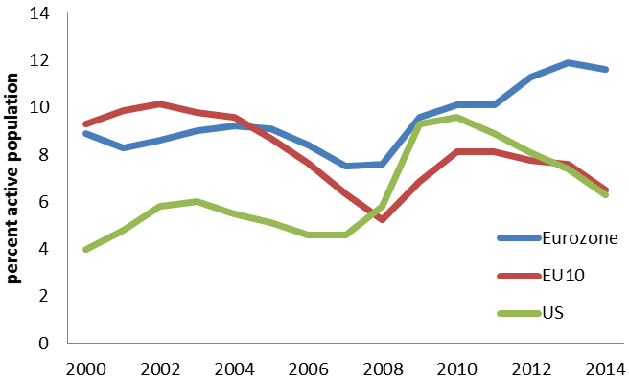
Source: European Commission, Ameco database.
Figures 1 and 2 also teach us that the Eurozone has failed dismally in delivering on the promises that were made at the start of the union; that is, that monetary union would lead to more economic growth and employment. The opposite has occurred. Member countries of the Eurozone have on average experienced less growth and more unemployment than the EU countries that decided to stay out of the Eurozone. Such an outcome, if maintained, undermines the social consensus in favour of a monetary union.

Fragility of the sovereign in the Eurozone
When the Eurozone was started, a fundamental stabilising force that existed at the level of the member-states was taken away from these countries. This is the lender of last resort function of the central bank. Suddenly, member countries of the monetary union had to issue debt in a currency they had no control over. As a result, the governments of these countries could no longer guarantee that the cash would always be available to roll over the government debt. Prior to entry in the monetary union, these countries could, like all stand-alone countries, issue debt in their own currencies thereby giving an implicit guarantee that the cash would always be there to pay out bondholders at maturity. The reason is that as stand-alone countries they had the power to force the central bank to provide liquidity in times of crisis.
What was not understood when the Eurozone was designed is that this lack of guarantee provided by Eurozone governments in turn could trigger self-fulfilling liquidity crises (a sudden stop) that would degenerate into solvency problems. This is exactly what happened in countries like Ireland, Spain and Portugal.²
- When investors lost confidence in these countries, they massively sold the government bonds of these countries, pushing interest rates to unsustainably high levels.
- The euros obtained from these sales were invested in ‘safe countries’ like Germany.
As a result, there was a massive outflow of liquidity from the problem countries, making it impossible for the governments of these countries to fund the rollover of their debt at reasonable interest rates.
This liquidity crisis in turn triggered another important phenomenon that we have documented in the previous section. It forced countries to switch-off the automatic stabilisers in the budget.
The governments of the problem countries had to scramble for cash and were forced into quick austerity programs by cutting spending and raising taxes. A deep recession was the result. The recession in turn reduced government revenues even further, forcing these countries to intensify the austerity programs. Under pressure from the financial markets and the creditor nations, fiscal policies became pro-cyclical pushing countries further into a deflationary cycle. In short:
- What started as a liquidity crisis degenerated, in a self-fulfilling way, into a solvency crisis.
Thus, we found out that financial markets acquire great power in a monetary union. They can force countries into a bad equilibrium3 characterised by increasing interest rates that trigger excessive austerity measures, which in turn lead to a deflationary spiral that aggravates the fiscal crisis, (see De Grauwe 2011, De Grauwe and Ji 2013). This was the same problem as that identified by Calvo (1988) and Eichengreen and Hausmann (2005) in emerging countries that are afflicted by an ‘original sin’ that forces them to borrow in foreign currencies.
Thus, in a monetary union, sovereigns singled out by financial markets cannot defend themselves unless they get help from other countries and from the ECB. But they are not willing to do this so easily.
The ECB recognised this problem when it started its OMT-program in 2012. This certainly helped to pacify financial markets at that time and avoided the collapse of the Eurozone. The issue arises of how credible the OMT-program is for future use. The ECB has been unwilling to use it during the latest Greek crisis. This refusal was based on the view that the Greek government is insolvent and, therefore, liquidity provision by the central bank is not the right remedy. This can lead to doubts about the future willingness of the ECB to provide liquidity to future governments in times of crisis.

Conclusion
The Eurozone crisis that emerged after 2010 was the result of a combination of two design failures.
- First, booms and busts continued to occur at the national level, leading to large external imbalances.
The lack of a smooth mechanism to correct for these imbalances created large economic and social costs.
- Second, the stripping away of the lender of last resort support from member states allowed liquidity crises to emerge when the booms turned into busts.
These liquidity crises then forced countries to eliminate another stabilising feature that had emerged after the Great Depression; that is, the automatic stabilisers in the government budgets. As a result, some countries were forced into bad equilibria.
As economists we should think harder about what happens to political systems when countries are forced into bad equilibria. As we have seen, in many countries where this happened, the political systems were badly shaken and extreme parties either increased in importance or came to power. In several of these countries the newly emerging political parties exhibit an open hostility to the monetary union and promise a better future outside the Eurozone.
When individual countries in a currency union get into debt problems, whether of their own making or not, they cannot stand on their own feet. They need the help of other countries and of the ECB. But this help is not unconditionally available. This leads to a potential for political conflicts between member-states of the union.
Many argue that countries can avoid being pushed into a debt crisis by adhering to strict fiscal discipline. Surely this is the proper response to what happened in Greece. But it is not for most other Eurozone countries that experienced a debt crisis after 2010.
- This ‘discipline’ view disregards a fundamental feature of a capitalistic system, which is that it is characterised by booms and busts; bubbles and crashes.
Booms are wonderful. Busts lead to misery for millions. In addition, they lead to dramatic increases in government budget deficits and debt levels even in countries following orthodox fiscal policies (Reinhart and Rogoff 2009, Shularick and Taylor 2012). I have argued here that the Eurozone is ill-prepared to face this instability of a capitalistic system.
The previous discussion points in the direction of a possible solution – it can only be provided by a political union. The latter does two things. Firstly, it can reduce too large divergences in macroeconomic policies that have often been the source of large economic imbalances between countries. Secondly, a political union provides for an automatic and silent assistance between countries.
But there's the rub. Most Eurozone countries are not prepared to step into a political union because they do not want to create a system of automatic assistance. Their mutual distrust is too large to do this.
The conclusion I draw from this today is the same as the conclusion I drew twenty years ago. If there is no willingness to step into a fiscal union (which can only exist in a political union), the euro has no future.

References
Baldwin, R (2015) “VoxEU told you so. Greek Crisis columns since 2009”, VoxEU.org, 21 June.
Bayoumi, T, and B Eichengreen (1993) “Shocking aspects of European monetary integration”, in F Torres and F Giavazzi (eds) Adjustment and growth in the European Monetary Union, London: CEPR, Cambridge University Press.
Calvo, G (1988) “Servicing the public debt: The role of expectations, American Economic Review, 78(4): 647‐661.
De Grauwe, P (1998) “The euro and financial crises”, Financial Times, February 20th.
De Grauwe, P (2011) “The governance of a fragile Eurozone”, CEPS Working Documents, Economic Policy, May.
De Grauwe, P, and Y Ji (2013) “From panic-driven austerity to symmetric macroeconomic policies in the Eurozone”, Journal of Common Market Studies, 51(S1): 31–41.
Eichengreen, B, R Hausmann, and U Panizza (2005) “The pain of Original Sin”, in B Eichengreen and R Hausmann (eds), Other people’s money: Debt denomination and financial instability in emerging market economies, Chicago University Press.
Feldstein, M (1997) “EMU and International Conflict”, Foreign Affairs, November/December.
Friedman, M (1997), “The euro: Monetary unity to political disunity?”, Project Syndicate, 28 August.
Gros, D (2011) “A simple model of multiple equilibria and default”, mimeo, CEPS.
Kenen, P (1969) “The theory of optimum currency areas: An eclectic view”, in R Mundell and A Swoboda (eds), Monetary problems of the international economy, Chicago: University of Chicago Press.
Krugman, P (1993) “Lessons of Massachusetts for EMU”, in F Torres and F Giavazzi, Adjustment and Growth in the European Monetary Union, London: CEPR, Cambridge University Press.
McKinnon, R (1963) “Optimum currency areas”, American Economic Review, 53: 717–25.
Mundell, R (1961) “A theory of optimal currency areas”, American Economic Review, 51(4): 657–65.
Obstfeld, M (1986) “Rational and self-fulfilling balance-of-payments crises”, The American Economic Review, 76(1): 72-81.
Reinhart, C, and K Rogoff (2009) This time is different: Eight centuries of financial folly, Princeton University Press.
Schularick, M, and A Taylor (2012) “Credit booms gone bust”, American Economic Review, 102(2): 1029-61.
Wolf, M (2014) The shifts and the shocks, Penguin Books, London.
Wyplosz, C (2011) “They still don’t get it”, VoxEU.org, 2

Quantitative easing in the Eurozone: It's possible without fiscal transfers
Paul De Grauwe, Yuemei Ji 15 January 2015
The ECB has been struggling to implement a programme of quantitative easing (QE) that would successfully target deflation. The main difficulty is political, stemming from opposition from German institutions. Their argument against is that a government bond buying programme by the ECB would mix fiscal and monetary policy. This column argues the opposite – such a programme can be structured so that it does not mix fiscal and monetary policy. It, therefore, would not impose a risk on German taxpayers.
184
a
A

Related
- Is the ECB doing QE?
Charles Wyplosz
- Fiscal implications of the ECB’s bond-buying programme
Paul De Grauwe, Yuemei Ji

Introduction
The ECB has been struggling to implement a programme of quantitative easing (QE) to counter the deflationary forces in the Eurozone. What one can say today is that it has not been very successful in stopping deflationary forces as is made vivid in Figure 1. We observe that since 2012 inflation has declined steadily in the Eurozone and became negative at the end of 2014. This trend has coincided with a spectacular decline in the balance sheet of the ECB and a concomitant decline in the money base (the liabilities side of the ECB’s balance sheet) since 2012. Figure 2 shows the balance sheets of the Fed and the ECB, and the strong contrasts in the development of the balance sheets of these two central banks. Figure 3 shows the money base in the Eurozone since 2010 and the spectacular decline in the money base since 2012.
Figure 1. Inflation in US and Eurozone
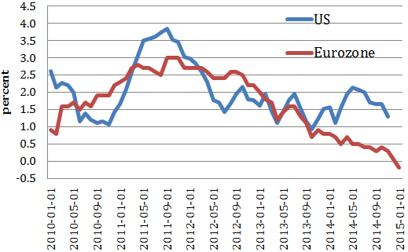
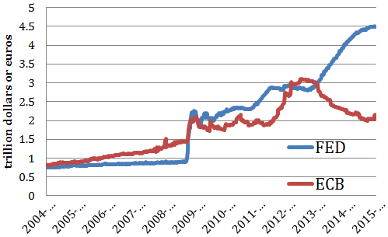Source: ECB.
In order to raise inflation, it will be necessary to increase the money base again. Note, however, that while necessary, this is not sufficient. The central bank liquidity must ultimately lead to an increase in bank credit and the money stock (see Friedman and Schwartz 1960). It is interesting to note that Friedman and Schwartz criticised the failure of the Federal Reserve in the 1930s to prevent the decline in the US money base. They argued that this failure contributed to the Great Depression. According to Friedman and Schwartz, the Fed failed to stop the decline of the money base as a result of a refusal to buy a sufficient amount of government securities.
An increase in the money base can be achieved by quantitative easing. The technically easiest way to implement QE consists in buying government bonds in the secondary markets. The reason why this is technically the easiest way to implement QE is that the market for government bonds is large and very liquid. As a result, it has been the standard approach in most central banks of the world. The Federal Reserve and the Bank of England have not hesitated to buy large amounts of government bonds to counter deflation in their respective countries, and they seem to have been more successful than the ECB.
The ECB, however, has found out that the technically easiest instrument of QE has become politically the most difficult one to use. This has to do with the intense hostility of the German Bundesbank, the German Constitutional Court, and of many German economists against the use of a government bond buying programme.
The most important argument used by the German opponents of a government bond buying programme by the ECB is that such a programme mixes monetary and fiscal policy.1 The argument goes as follows. When in the context of QE the ECB buys government bonds from fiscally weak countries it takes a credit risk. Some of these countries may default on their debt. This then will lead to losses for the ECB, which, in turn, means that the taxpayers of the fiscally sound member countries of the Eurozone (mainly Germany) will be forced to foot the bill. Thus, when the ECB buys government bonds, it creates a risk that future taxpayers will be liable to bear losses. Put differently, the ECB is, in fact, conducting fiscal policies in that it organises fiscal transfers between member states. The ECB has no mandate to do so.
This argument has been defended in various wordings by the Bundesbank (2012), Weidmann, the President of the Bundesbank, the German Constitutional Court (BvR 2014), and well known German economists (Sinn 2013, Weber 2010, among others). It has now become the generally accepted narrative among many German economists. Yet, it is wrong.
We will argue in this column that a government bond buying programme by the ECB can be structured in such a way that it does not create any risk for the German taxpayer and that, therefore, there is no mixing of monetary and fiscal policies when the ECB buys government bonds.

The basics
Let us start with the basics. When a central bank buys government bonds, it substitutes one type of liabilities of the public sector with another one. Government bonds that promise a fixed interest rate are replaced by a monetary liability without interest but carrying an inflation risk. At the moment of the purchase, the government bonds cease to exist. All that is left of the bonds is a monetary liability of the central bank (which is one branch of the public sector).
Of course, typically the central bank keeps the government bonds on its balance sheet, thereby creating the fiction that these bonds still exist. These bonds, however, are just a claim of one branch of the public sector (the central bank) against another branch of the public sector (the government). These two branches should be consolidated into the public sector, and then it turns out that these claims and liabilities cancel out.
Another way to see the same thing is by considering the flows. When the government bonds are kept on the balance sheet of the central bank, the government transfers interest to the central bank. The latter then transfers this interest revenue back to the government. The central bank could easily stop this fiction and put the bonds in the shredding machine. It would make no difference. No taxpayer is involved. The fact that the bonds are destroyed does not produce a new risk for the taxpayers.
Note that the fiscal implications arise at the moment of the purchase of the bonds by the central bank. At the moment these bonds are taken out of circulation, the government does not have to pay interest anymore. (The interest payments to the central bank are just a bookkeeping affair because the government gets them back). Prior to the purchase, the government had to make these interest payments and thus had to tax citizens to make this possible. Therefore, the purchase of the bonds by the central bank relieves taxpayers. The price the taxpayers pay is that there might be more inflation. But when this operation is performed to fight deflation (i.e. to increase inflation) as is the case today, this should, in fact, increase the taxpayers’ welfare. What happens afterwards with these bonds on the balance sheet of the central bank is of no importance to the taxpayers.
Put differently, the value at which the bonds are kept on the balance sheet of the central bank has no bearing for the taxpayer.
These bonds could be given a value of zero or any other value without any taxpayer suffering or gaining from this. Does this conclusion also hold in a monetary union like the Eurozone? The answer is yes, provided we structure the bond buying programme carefully. We show this in the next section.

Government bond purchase and fiscal transfers in a monetary union
Suppose the ECB buys an amount of government bonds of €1,000 (this is the amount by which the ECB wants to increase its balance sheet) and distributes the purchases of individual countries’ bonds according to the equity shares of the member countries in the Eurozone. We show these equity shares and the corresponding amounts of national bond purchases in Table 1.
These government bonds are held on the balance sheet of the ECB and lead to interest payments of each government to the ECB. These interest payments are profits made by the ECB that will have to be returned to the national central banks, which will return these to the national treasuries. If we use the same equity shares to return the interest payments and if the interest rates on these national bonds are the same, the ECB will return exactly the same amount of interest it has received from the national treasuries back to the same treasuries. (We discuss the case where the interest rates are not the same later).
The purchase has the following fiscal implications in each country. Taxpayers in each country have to pay less tax because the bonds held by the ECB do not lead to interest expenses of the respective governments anymore. The taxpayers have an inflation risk instead. But since the purpose of the purchase is to increase inflation to a higher and more optimal level, the welfare of the taxpayers increases.
The important point to make, however, is that no fiscal transfers between member countries are involved. The German taxpayers gain because part of the German debt is monetised; the Italian taxpayers gain because part of the Italian debt is monetised. This is the effect each of these countries had before they were in the monetary union when their national central banks in the context of their monetary policies were buying national government bonds.
Table 1. Equity shares of member countries in ECB and distribution of bond purchase
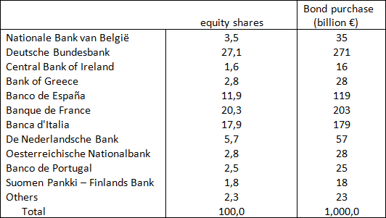
Now suppose that one of the member countries’ governments defaults (the big scare of most German economists). To make it more dramatic, suppose it is Italy. In that case, the Italian treasury will cease to pay interest to the ECB. If the ECB then uses the rule (which is easy to enforce) that it will not transfer interest to the Banca d’Italia, the other governments will get back exactly what they have paid to the ECB. German, Dutch, Finnish, etc. taxpayers will not be involved and will not have to pay a penny extra. In fact, the Italian taxpayers will not gain anything either. The Italian treasury does not pay interest to the ECB anymore and does not get anything in return from the ECB.2 Thus, this particular way of structuring the bond purchase and interest payments leads to the same neutrality result that we discovered in the case of a single country – the value of the bonds held by the central bank has no bearing for the taxpayers. There are no fiscal transfers arising from the fact that the Italian government has defaulted. The German taxpayer does not have to foot the bill.
We made the assumption that the interest rates on the government bonds held by the ECB are equal. In general, this is not the case. The interest rate on the government bonds of the fiscally prudent governments is usually lower than the interest rate on the bonds of fiscally less prudent governments. Thus, the interest rate on German bonds is lower than on Italian bonds. What are the implications?
It is easy to show that this will lead to a fiscal transfer towards the taxpayers of the fiscally prudent country, Germany in our example. The reason is that the Italian treasury pays more interest to the ECB than the German treasury. Thus, the profits that the ECB makes contain relatively more Italian than German interest revenues. But this profit is redistributed according to the equity shares. Thus, Germany will receive a net positive interest flow made possible by a net negative interest flow from Italy.
- There is a fiscal transfer, but it is not the one so much feared by the President of the Bundesbank and German economists. The German taxpayer is a net recipient from this QE operation.
What happens if in this case Italy were to default? The answer is that the net positive interest flow in favour of the German taxpayer stops. It would be stretching the meaning of words to call this ‘footing the bill’ by German taxpayers.
- An Italian default would only imply that the German taxpayer stops enjoying the fiscal transfer resulting from the bond buying programme by the ECB.
It is possible to completely eliminate this type of fiscal transfer between Italy and Germany, however. This can be achieved by following a somewhat different interest distribution rule. Instead of pooling the interest payments the ECB receives and then distributing them according to the equity shares, one could also use a rule of ‘juste retour’. This would mean that the ECB redistributes the exact amounts of interest payments it has received from each member government back to the same government. If this rule is applied, it can easily be seen that the neutrality result holds perfectly. There would be no net interest transfer from Italy to Germany before or after the default. Complete neutrality is restored and taxpayers are shielded from movements of the value of the bonds on the ECB’s balance sheet.

Permanent vs. temporary bond purchases
The previous discussion developed the case of a permanent purchase of government bonds, i.e. the government bonds are permanently kept on the ECB’s balance sheet. It is likely, however, that, in the future the ECB will want to sell part of the governments bonds it has acquired today back in the secondary market. At that moment, monetary liabilities of the ECB (and thus the money base) will decline again and government bonds will be put back into circulation. This will have a fiscal implication, i.e. the national governments will have to pay interest to the new holders of these bonds (private investors) that will not be reimbursed anymore, as was the case when the bonds were held by the ECB.
However, if the sales of government bonds occur according to the same equity shares used for the purchase, there will be no fiscal transfers between countries. The German government will be confronted with the need to pay interest on German government bonds as it did before the bonds were bought by the ECB. The same is true for the other governments. Thus, future sales of government bonds can be tailored in such a way that they do not lead to fiscal transfers between member countries. German taxpayers can sleep peacefully – they will not have to foot the bill of other governments.
What happens if before the future sales of government bonds a member country defaults? Let us assume again this is Italy. In this case, the issue arises of whether the ECB will have enough government bonds left over to sell. It can immediately be seen that this is not likely to lead to a problem, at least if the ECB does not want to sell the full amount of the bonds acquired by the QE operation. Since the ECB has shrunk its balance sheet so much since 2012 (see Figure 2), it will want to restore a balance sheet size corresponding to the one existing before the Crisis. Extending the trend that existed before 2008 to the present period implies that the ECB is likely to keep at least €500 billion of the €1 trillion acquired through QE on its balance sheet. In that case, only €500 billion would have to be sold. One would need a catastrophic number of countries defaulting before the ECB runs out of bonds to sell.
One can conclude that the need to create additional money base to achieve the inflation target of 2% makes it possible to write down a significant part of the government debt on the ECB’s balance sheet without creating fiscal transfers between member states. This is also the conclusion arrived at by Paris and Wyplosz (2014).

Conclusion
The ECB has been prevented from doing what is necessary, i.e. to increase the money base so as to maintain its objective of keeping inflation close to 2%. It has been prevented from acting as a result of an intense opposition of major German institutions and of a large segment of the community of German economists. The surprising thing about this opposition is that it has been based on a wrong interpretation of the fiscal implications of QE, i.e. that this will lead to fiscal transfers between member countries. One could have expected that German central bankers and German economics professors understand the nature of monetary policy in a monetary union. One is surprised that this knowledge has been set aside and a myth has been created that has helped to stir an irrational fear in Germany against the use of a monetary policy instrument that in most developed nations is considered to be best practice.

References
Bundesverfassungsgerich, BvR 2728/13 of 14 January 2014 (OMT Ruling), para. 70
De Grauwe, P, and Y Ji (2013), “Fiscal implications of the ECB’s bond buying programme”, VoxEU.org, 14 June.
Deutsche Bundesbank (2012), “Stellungnahme gegenüber dem Bundesverfassungsgericht zu den Verfahren mit den Az. 2 BvR 1390/12, 2 BvR 1421/12, 2 BvR 1439/12, 2 BvR 1824/12, 2 BvE 6/12” [Statement to the Federal German Constitutional Court in the Proceedings with Reference Nos. 2 BvR 1390/12, 2 BvR 1421/12, 2 BvR 1439/12, 2 BvR 1824/12, 2 BvE 6/12].
Friedman, M, and A Schwartz (1960), The Monetary History of the United States, Princeton Universtity Press.
Gerner-Beuerle, C, E Kücük and E Schuster (2014), “Law meets economics in the German Federal Constitutional Court”, London School of Economics, unpublished.
Opinion of Advocate General Cruz Villalon, delivered on 14 January, 2015, InfoCuria, Case-Law of the Court of Justice.
Paris, P and C Wyplosz (2014), "The PADRE Plan. Polically Acceptable Debt Restructuring in the Eurozone", VoxEU, January.
Sinn, H-W (2013), “Verantwortung der Staaten und Notenbanken in der Eurokrise”, [Responsibilities of Governments and Central Banks in the Euro Crisis].
Weber, A (2010). ´Kaufprogramm birgt erhebliche Risiken´ [Bond Program Carries Substantial Risks) Börsen-Zeitung, 11th May, No. 89, 1
Weidmann, J, (2014), interview in the Wall Street Journal, October, 2014
Winkler, A, (2014), “The ECB as Lender of Last Resort. Banks versus Governments”, LSE Financial Markets Group, Special Paper Series, February.

Footnotes
1 We have analysed the other arguments often used in Germany in De Grauwe and Ji (2013) and found them wanting. See also Winkler(2014) and Gerner-Beuerle, et al.(2014). Also we do not go into legal arguments. A preliminary ruling of the European Court of Justice suggests that a bond-buying program in the context of the ECB’s monetary policy is legal.
2 Note that this neutrality effect only holds for the Italian government bonds held by the ECB, not for the Italian bonds held by the public.

