Financial Globalization and the Welfare State
by
Assaf Razin and Efraim Sadka
The Eitan Berglas School of Economics the Eitan Berglas School of Economics
Tel Aviv University Tel Aviv University
Tel Aviv, 69978, Israel Tel Aviv, 69978, Israel
razin@post.tau.ac.il sadka@post.tau.ac.il
November 15, 2018

Abstract
Globalization, in the form of financial flows, which is always advantageous on an aggregative level, typically creates winners and losers, if left exclusively to market forces. The paper demonstrates that typical welfare-state redistribution policies, governed by a majority of the population, spreads the globalization’s gains from trade to all income groups, even those who are low skilled and have small capital endowments. Therefore, financial globalization of a welfare- state economy generates a Pareto improvement.

- Introduction

The Economist put it succinctly: “Globalization is a tax problem for three reasons. First, firms have more freedom over where to locate. This will make it harder for a country to tax a business much more heavily than its competitors. Second, globalization makes it hard to decide where a company should pay tax, regardless of where it is based. This gives them [the companies] plenty of scope to reduce tax bills by shifting operations around or by crafting transfer pricing. Third, globalization nibbles away at the edges of taxes on Individuals. It is harder to tax personal income because skilled professional workers are more mobile than they were two decades ago." (The Economist, 31st May, 1997).
Financial globalization triggers a race-to-the-bottom tax competition. The consequent erosion in the tax base, especially on capital, erodes fiscal finance. Reaping the benefits of trade and financial integration, in advanced countries, is not automatic. It requires improved safety nets.

The paper focuses on the role of the welfare state in spreading the gains from financial globalization to various income groups under different majority voters, who are sharply different in their wealth and labor market skills.

The paper is organized as follows. Sections II-IV provides some background discussion on financial globalization, tax competition, and the size of the welfare state, which serves to motivate the analysis. Section V develops a stripped down model. Section VI presents the financial-globalization consequences, derived from the model for the welfare state and income inequality. Section VII elaborates on the role of the welfare state in compensating losers. Section VIII concludes.

- Recent Trends in Financial Globalization
The recent wave of financial globalization in the world economy got started in earnest in the 1990s, with rising cross-border financial flows among industrial economies and between industrial and developing economies. This was spurred by liberalization of capital controls in many of these countries. It is useful to begin with a standard financial globalization basic benchmark. Complete international financial integration requires that in the long run (when prices adjust to various shocks and markets clear) the following arbitrage equation holds.
$$\left(1\right) 1+r_{t}^{US}=\left(1+r_{t}^{i}\right)\frac{q_{i/{US}, t+1}}{q_{i/{US}, t}} ,$$
Where US serves as a benchmark, $i$ stands for a country, and q stands for the real exchange rate Vis a Vis the US dollar:
$${\left(2\right) q}_{i/{US}, t}^{t}=E_{i/{US},t}\frac{P_{US,t}}{P_{i,t}} ,$$

The symbol $E$ stands for the nominal exchange rate, Vis a Vis the US dollar; and $P$ stands for the price level.
To demonstrate trends in this indicator of recent financial globalization, Figure 1 plots the graphs of the real-interest-rate, adjusted for real exchange rate changes, the yields on three-month government bonds for Israel, Canada, Germany and the United Kingdom, and the yields on three-month US government bonds. International financial integration generates more synchronized country-specific yields. Time series are filtered to wash out short-run idiosyncratic fluctuations.
Figure 1: Gross Real Interest Rate Adjusted for Real Exchange Rate Changes (US =1.00)
Note: Series are HP-filtered. Monthly data are shown in the background.
Source: Stats Bureau, FERD, World Bank, Real-exchange-rate adjusted, yields on three-month government bonds for Israel, Canada, Germany and the United Kingdom, and the yields on three-month US government bonds.

Figure 1 demonstrates vividly that in the late 1990s and early 2000s real interest rate, adjusted for real exchange rate of Canada, Germany, Israel, and the United Kingdom converged towards the US real interest rate; implying that their financial markets integrated significantly into the world financial markets.
III. Tax Competition: Evidence
Financial globalization triggers tax competition among countries, and the possibility of a “race to the bottom”. As a result, the tax burden may shift from the highly mobile factors (e.g. capital and top-skilled labor) to the weakly mobile factors (e.g. low-skill labor). This shift has first-order implications for both the functional and the size distribution of income. A country that imposes high tax rates may push mobile factors (especially capital) abroad where the country cannot effectively tax them, eroding its own tax base and lowering domestic economic activity at the same time. International tax competition and border tax adjustments of income tax have regained recent public and scholarly attention since the legislation of the 2017 US Tax Bill, centered on corporate tax cut and moving from corporate residence based in the direction of corporate source-based, and curbing profit shifting. It may significantly affect corporate financing and location decisions of both US, and European, multinational groups. In consequence, the enhanced competitive pressure could result in an erosion of foreign countries’ tax bases and an associated loss in tax revenue triggering a new wave of international tax competition.
Figure 2: Hall-Jorgenson Effective Tax Rates on Corporate Income: Selected EU Countries

Notes:

Notes: Hall and Jorgenson (1967. Assumptions: Equity finance, r = 4 %, inflation rate π = 4 %, δ = 20 %, Normal tax life = 10 years
2.countries (from top to bottom): Finland, Sweden, Germany, Austria, UK, Belgium Denmark, France, Italy, Luxemburg, Spain, Portugal, Netherlands, Ireland.

One can clearly detect in Figure 2 a noticeable breakpoint pointing to a significant corporate income tax cuts, at the end of the 1980s in the wake of the single market launch in mid 1990s. Overall, the mean EU effective corporate tax rate went down from 42% in 1975 to 32% in 2000, and the standard deviation went down from 8% in 1975 to 5.8% in 2000.
IV. Declining Welfare State: Evidence
The general rules of making the welfare state less generous are quite straightforward: lower taxes on capital income, and highly mobile labor, and curtail benefits.
In recent years, at the same time that the financial integration of the world economy built up, most of the large industrialized economies have embarked on a track of trimming the generosity of their pension and other welfare-state programs. This is not a coincidence. Financial integration lower the tax on the mobile factor, capital, and weakens the capital income tax base. Caminada et al (2010) explored EU welfare-state indicators. Using a variety of indicators of social protection: social expenditures, both at the macro and at the program level, replacement rates of unemployment, and social assistance benefits and poverty indicators. Together, these indicators may provide a relatively broad picture of the evolution of social protection in the EU. Table 1 demonstrates that the initial level of public social expenditure prior to the creation of the EU, has a negative effect on the on EU provision of public social services well after EU has been established. We conjecture that these patterns may have to do, among other things with the globalization forces that were unleashed by the integration of Europe.

Table 1. Convergence of Public Social Expenditures in EU‐15 Controlled for Cyclical and Demographic Effects, 1985–2003
 |  |  | Public Social Expenditures
Initial level public social expenditure 1985 (β) |  |  | −0.035**
 |  |  | (−3.67)
Unemployment rate |  |  | 0.460*
 |  |  | (2.95)
Intercept |  |  | 0.942**
 |  |  | (4.23)
adj. R² |  |  | 0.534
Source: Caminada, Goudswaard, and Van Vliet (2010).
Notes: OLS‐regression; t‐statistics in parentheses. ** Significant at the 0.01 level;* significant at 0.05 level.

V. A Stripped-down Model
To put financial globalization, tax competition, and the generosity of the welfare state into a coherent analytical framework we develop here an international-tax- competition model where the welfare state parameters (taxes and social benefits) are determined through majority voting (Razin and Sadka 2018). We consider a two-period small open economy which responds to exogenously given world interest rate, taxes, an imperfect accessibility to international capital markets and strong elements of source-based taxation. The welfare state provides a uniform social benefit. This social benefit captures the various ingredients that the welfare state accords, such as health services, education, in-kind transfers, and so on. Domestic taxes on labor income and capital income are proportional. The degree of globalization is captured by the ease of moving capital abroad. We employ a stripped-down model which includes the bare elements that will enable us to study key implications of international capital flows and international tax competition on the welfare state. We assume a pure source-based (territorial) taxation. This means that the country does not impose taxes on foreign-source income.
The representative producer equity-finance its activity, and all international capital flows are in the form of equity securities. We consider a two-period small open economy which responds to exogenously given world interest rate, taxes, and an imperfect accessibility to international capital markets. There is one all-purpose composite good (allowing us to abstract from trade issues) which can serve for both consumption and capital investment. There are two types of factors of production—capital (K) and labor (L). The workers have two types of skills—low (l) and high (h).
The production function is Cobb-Douglas,
(3) $F\left(K,L\right)=AK^{α}L^{1-α}$,
With constant returns to scale, where A$>0$is a total productivity parameter, and $α$and $1-α$ are, respectively, the capital and labor shares.
Individuals live for two periods (1, and 2), so that there are essentially two consumption goods: first-period consumption ($c_{1}$) and second-period consumption ($c_{2}$). Labor is internationally immobile, whereas capital is mobile. Individuals can direct their savings at home and/or abroad.

Total size of the population is normalized to one. Labor supply (L) is measured in efficiency units. We assume that there are $γ$ high-skill individuals, each providing one efficiency unit of labor, and $1-γ$ low-skill individuals, each providing $ρ<1$ efficiency units of labor. Thus, total labor supply in efficiency units is given by
$\left(4\right) L=γ-m_{h}+(1-γ)ρ$.
Where $m_{s}$ denotes the emigration of skilled individuals. Emigration depends on skilled utility level:

$$m_{h}={m(u}_{h})$$
The lower the skilled utility, $u_{h}$ , is, the higher is the rate of emigration,$m_{h}$.
Capital is invested in the first period and output accrues in the second period. Factor remunerations are also paid in the second period.
The wage per efficiency units and the domestic return to capital, are given by the marginal productivity conditions:
(5) $w=(1-α){(K/{L)}}^{α}$
And,
(6) $1+r=α{(L/{K)}}^{1-α}$,

Where the composite-good price is normalized to one. The specification in equation (4) assumes that capital fully depreciates at the end of the production process.

Capital flows internationally, albeit at some cost- $δ$ per unit. An individual who invests abroad can thus gain $1+\left(1-t_{K}^{*}\right)r^{*}-δ$ , where r* is the world rate of interest, and $t_{K}^{*}$ is the tax rate levied abroad under a source-based taxation. In a small open economy context, the three variables, ( $t_{K}^{*}$ $, r^{*}and δ$ ) play an equivalent role, where the only relevant variable is$\left(1-t_{K}^{*}\right)r^{*}-δ$. Denoting the domestic tax rate on capital by $t_{K}$ , arbitrage possibilities yield:

(7) $1+\left(1-t_{K}\right)r=1+\left(1-t_{K}^{*}\right)r^{*}-δ$.
For the sake of simplicity, we consider only the case where the equilibrium levels of saving abroad is positive; that is there are capital outflows but not capital inflows.
Each high-skill individual is endowed with one unit of the composite good in the first period; a low-skill individual is endowed only with $θ<1$ units. Thus, an h-skill individual enjoys both higher initial endowment (“wealth”), and higher labor market skill than the l-skill individual.
We assume Cobb-Douglas preferences for both types of individuals,

(8) $u=c_{1}^{β}c_{2}^{1-β}+b^{σ}$,
Where, $0< σ < 1$.
The welfare state provides a uniform social benefit (b). This social benefit captures the various ingredients that the welfare state accords; such as health services, education, in-kind transfers, etc.
These preferences yield the following consumption functions:
(9) $c_{1l}=\frac{β[ \left(ρw(1-t_{L}\right)+ \left(1+\left(1-t_{K}^{*}\right)r^{*}-δ\right)θ] }{1+\left(1-t_{K}^{*}\right)r^{*}-δ}$

(10) $c_{2l}=(1-β)\left(ρw(1-t_{L})+[1+\left(1-t_{K}^{*}\right)r^{*}-δ]θ\right)$

(11) $c_{1h}=\frac{β\left(\left(\left(w(1-t_{L}\right)+ \left(1+\left(1-t_{K}^{*}\right)r^{*}-δ\right)\right)\right)}{1+\left(1-t_{K}^{*}\right)r^{*}-δ}$
(12) $c_{2h}=(1-β)\left(w(1-t_{L})+[1+\left(1-t_{K}^{*}\right)r^{*}-δ]\right)$.
The welfare state employs taxes on labor income ($t_{L}$) and capital income ( $t_{K}$ ) in the second period and provides the social benefit (b).
We denote by $S^{*}$ the (positive) aggregate investment abroad, so that the first-period resource constraint is:
(13) $K+S^{*}+γc_{1h}+\left(1-γ-m_{S}\right)c_{1l}=γ-m_{S}+(1-m_{S})θ$.
The second-period resource constraint is:
(14) $b+(γ{-m_{S})c}_{1h}+\left(1-γ\right)c_{1l}=F\left(K,L\right)+\left\{1+\left(1-t_{K}^{*}\right)r^{*}-δ\right]S^{*}$.
The government budget constraint is active only in the second period, and its budget constraint is given by
(15) $b+t_{L}\left((1-γ)ρ+\left(γ-m_{S}\right)\right)w+t_{K}rK$.
Note that by Walras’ Law, the government budget constraint is redundant. (Note also that with source-based taxation, the return on $S^{*}$ is not taxed at home.)
The policy employed by the welfare state depends on which of the two groups of individuals (l and h) form the majority. That is whether $γ$ is greater or smaller than$1-γ-m_{S}$. The policy variables are$t_{L}$, $t_{k}$ and b. When the low –skill group form the majority (that is, $γ<0.5$), the policy variables are chosen so as to maximize $u_{l}=c_{1l}^{β}c_{2l}^{1-β}+b^{σ}$. And when the high-skill individuals are in the majority (that is, $γ>0.5$), the policy variables are chosen so as to maximize $u_{h}=c_{1h}^{β}c_{2h}^{1-β}+b^{σ}$.
As was already mentioned, taxes are levied, and social benefits are granted only in the second period. Nevertheless, these policy variables are determined, announced, and committed to, already in the first period by the fully informed, and dynamically consistent policy makers.
Our objective is to study how these policies respond to changes in the process of globalization, driven by changes in the parameters $t_{K}^{*}$, $r^{*}$, and $δ$. In particular, the response of b may be viewed as the effect on the generosity of the welfare state, and the effect on $t_{K}$ captures the international tax competition. We are also interested in the effects on the consumption-equivalent utility levels to gauge the effects of globalization on income distribution, and the benefits from globalization.
For this purpose, and given the multitude forces at play, we resort to numerical simulations.
The parameter values employed in these simulations are as follows: $β$= 0.6, $θ=0.5, α=0.33, γ=0.5, ρ = 0.6, r^{*} = 2.4, t_{K}^{*} = 0.4, A = 1.$The share in the population of high skill type in the population $(λ)$ is either 0.6, when they are the majority, or 0.4, where they are in the minority.

VI. Model’s Predictions
The degree of globalization is captured by the ease of moving capital abroad. Specifically, we assume that there is some cost,$δ$, per unit of investment abroad. By raising the cost parameter, we raise or lower the intensity of globalization. The incentive for engaging in tax competition is triggered by lowering the foreign tax on capital, $t_{K}^{*}$. Recall that capital flows take only the form of equity capital, not debt.
The degree of globalization is measured by the cost parameter $δ.$ We study therefore the implications of changing $δ$ for the economy in general (e.g. the allocation of capital between domestic and foreign uses), and for the tax burden, its composition, and the generosity of the welfare state, in particular.
As expected, Figures 3 and 4 show that financial globalization (i.e. lowering $δ)$
Shifts capital from home abroad. This is true no matter whether the high-skill or the low-skill form the majority. Naturally, both capital invested at home and abroad, are higher when the high-skill form the majority, than when the low-skill form the majority.

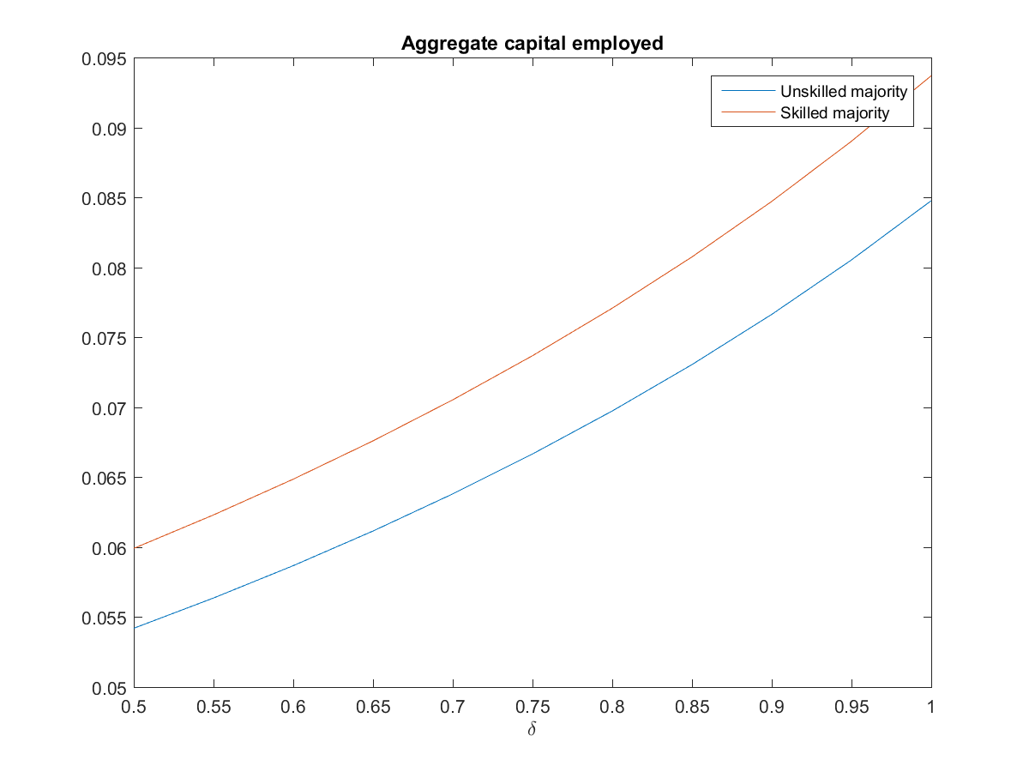
High-skilled majority
Low-skilled majority
Figure 3: Capital Invested Domestically

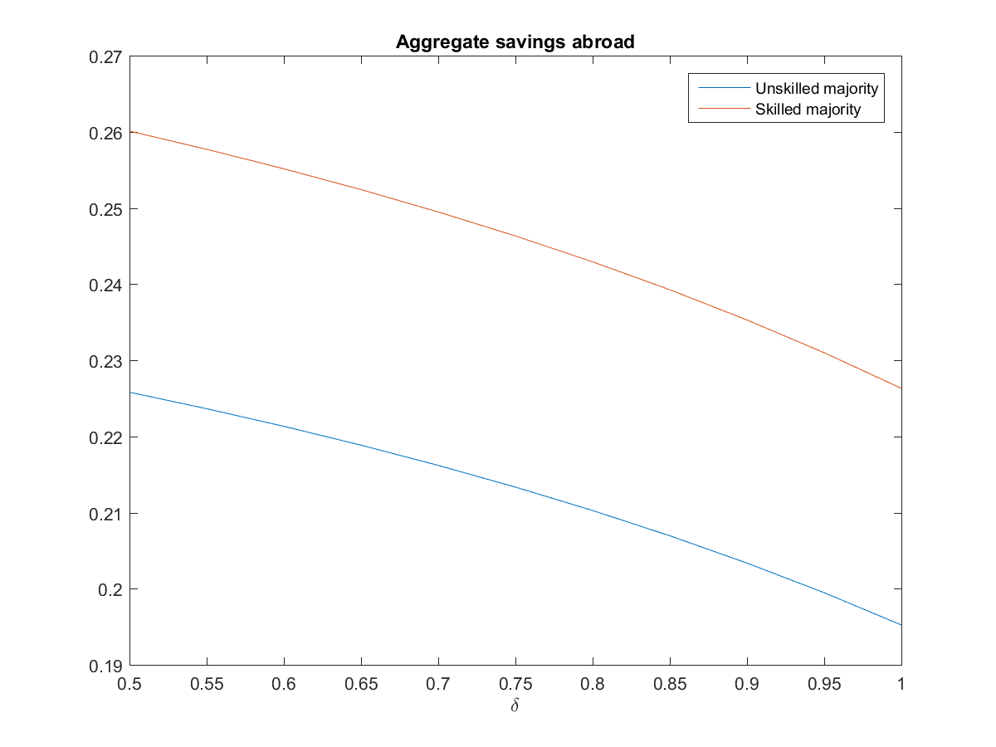
Low-skilled majority
High-skilled majority
Figure 4: Capital Invested Abroad

Also, as domestic capital falls with financial globalization, the rate of return of domestic capital rises and the wage rate falls.
Turning our attention to the welfare-state system, Figures 5 and 7 show that financial globalization shifts the tax burden away from domestic capital income to labor income. It also lowers the total tax burden, and consequently, the provision of the social benefit (b). These results obtain regardless of which skill type form the majority. Naturally, the tax rates on capital and labor are higher when a low-skill type form the majority, than when the high-skill type forms the majority.

Figure 5: Tax Rate on Domestic Capital Income 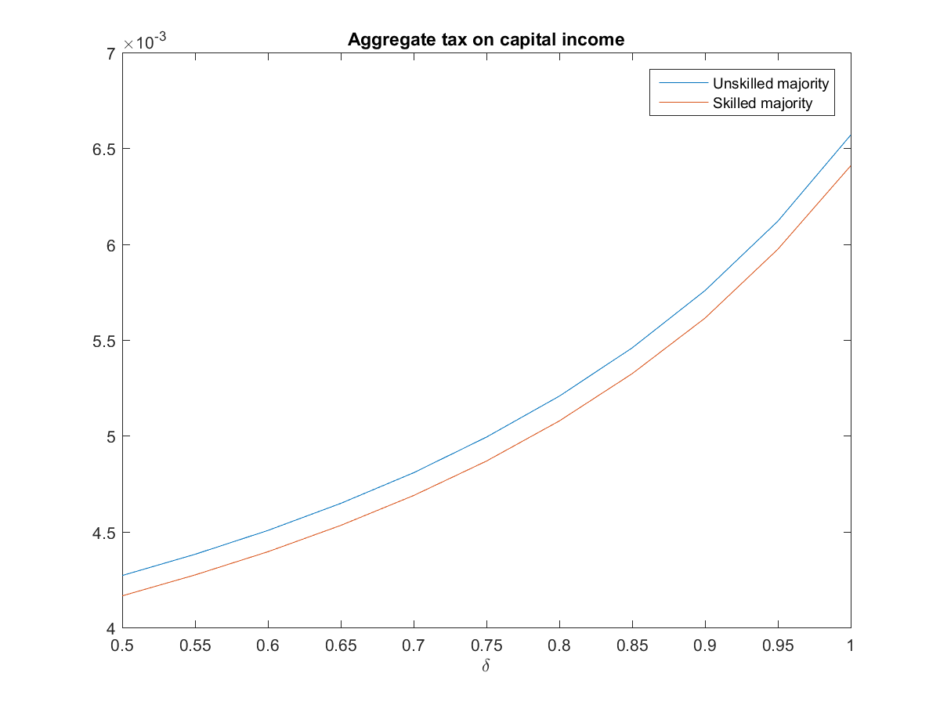
High-skilled majority
Low-skilled majority
Figure 6: Tax Rate on Labor Income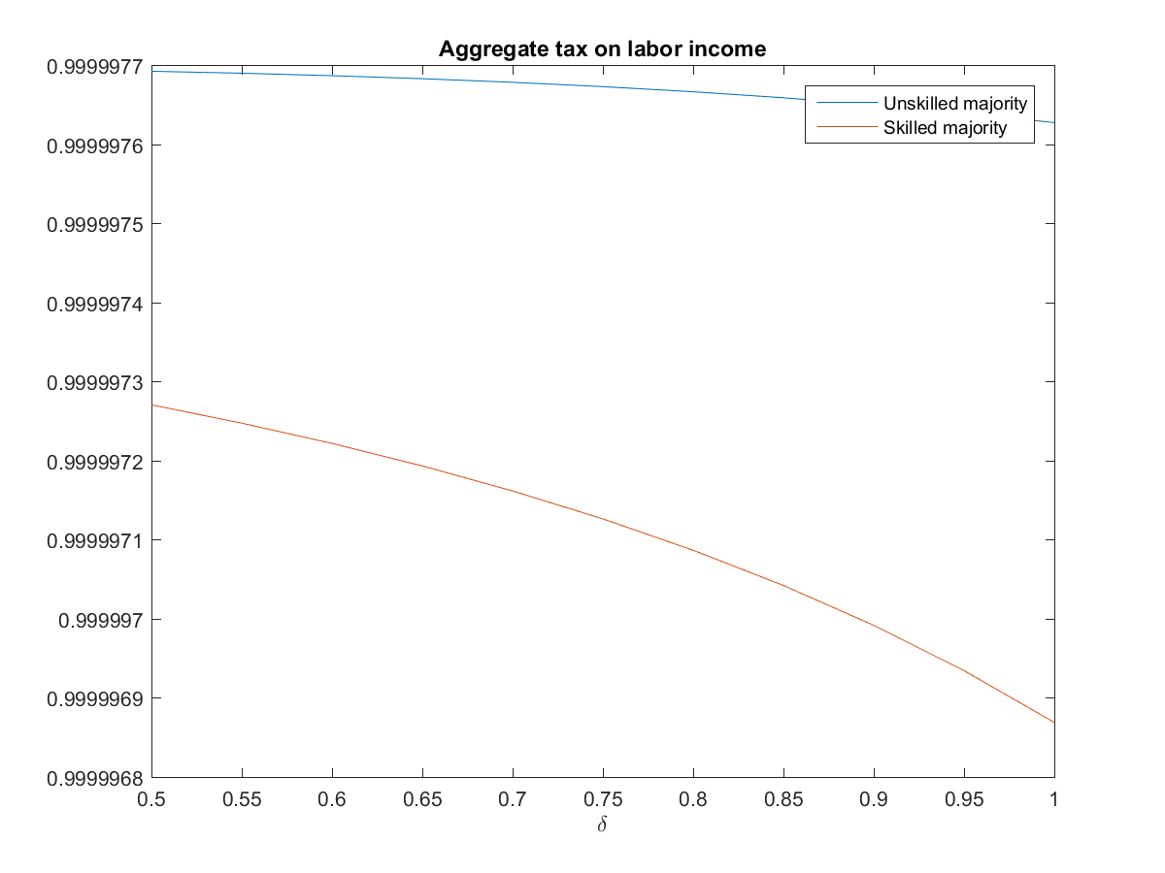
Low-skilled majority
High-skilled majority
Low-skilled majority
Figure 7: Social Benefits
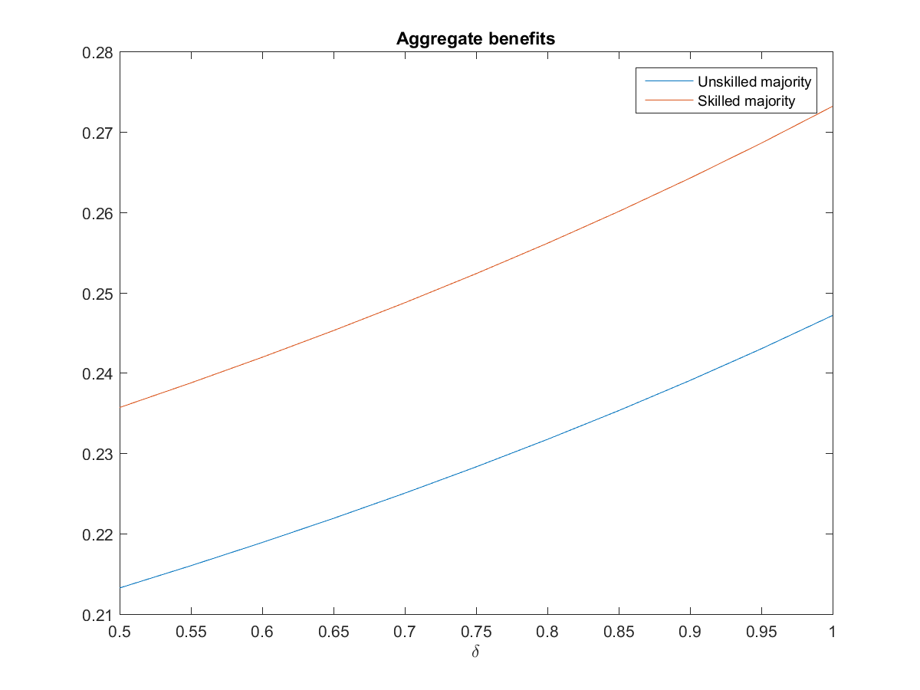
Low-skilled majority
High-skilled majority

Comparing the levels of the social benefit under the two regimes, there are two forces at play. On the one hand, the tax rate is higher under a low-skill majority. On the other hand, the economy is less productive when the low-skill labor is the larger component of the labor force. This force reduces the total tax revenues. In our simulations, the second effect dominates. As a result, the social benefit (b) is lower under the low-skill regime.
Turning now to who is the winner and who is the loser from financial globalization, we note that the issue is far from being a straightforward application of a gains-from-trade argument. For an existence of Pareto improvement to work in a multi-consumer economy, it is an essential to have a specific way for the redistribution policy, so as to compensate the losers by taxing the winners. However, our model’s redistribution system is constrained by who is the majority, low-skilled or high-skilled.

Figure 8: Utility Level of High-Skill Individuals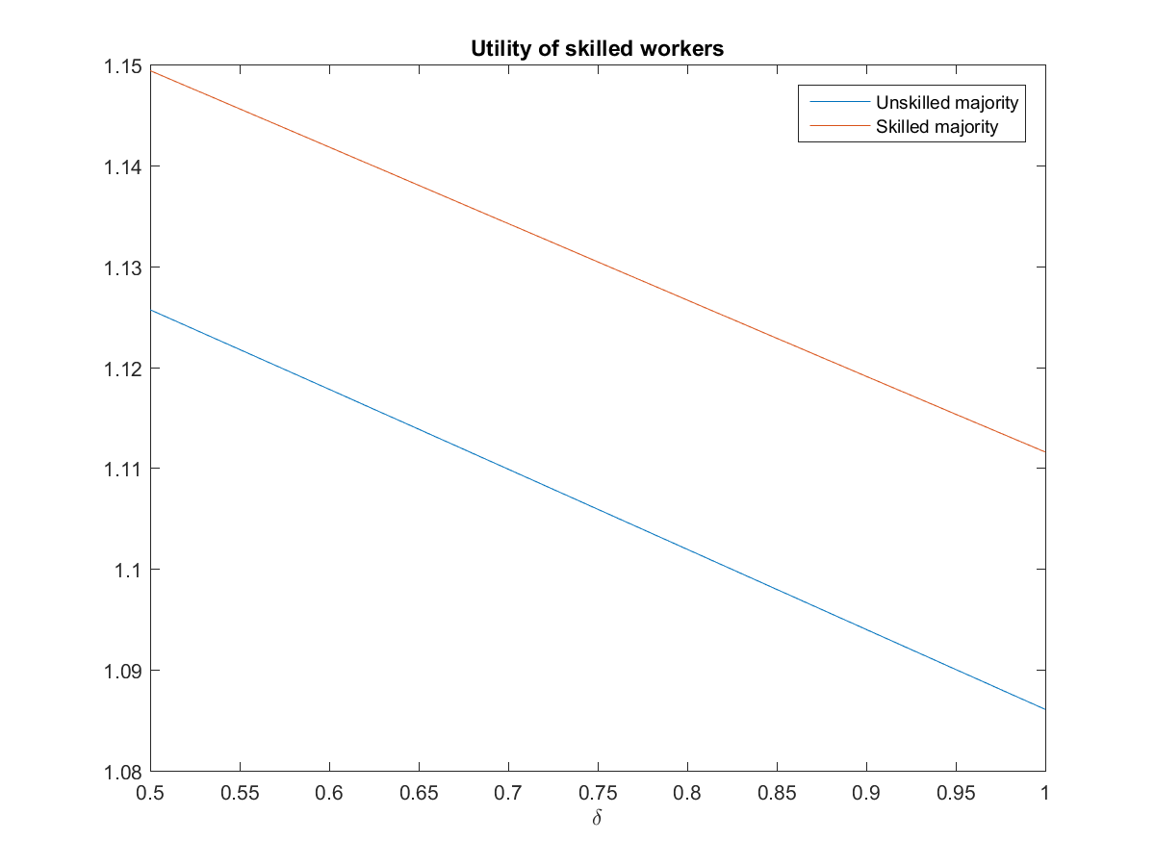
Low-skilled majority
High-skilled majority

Figure 9: Utility Level of Low-Skill Individuals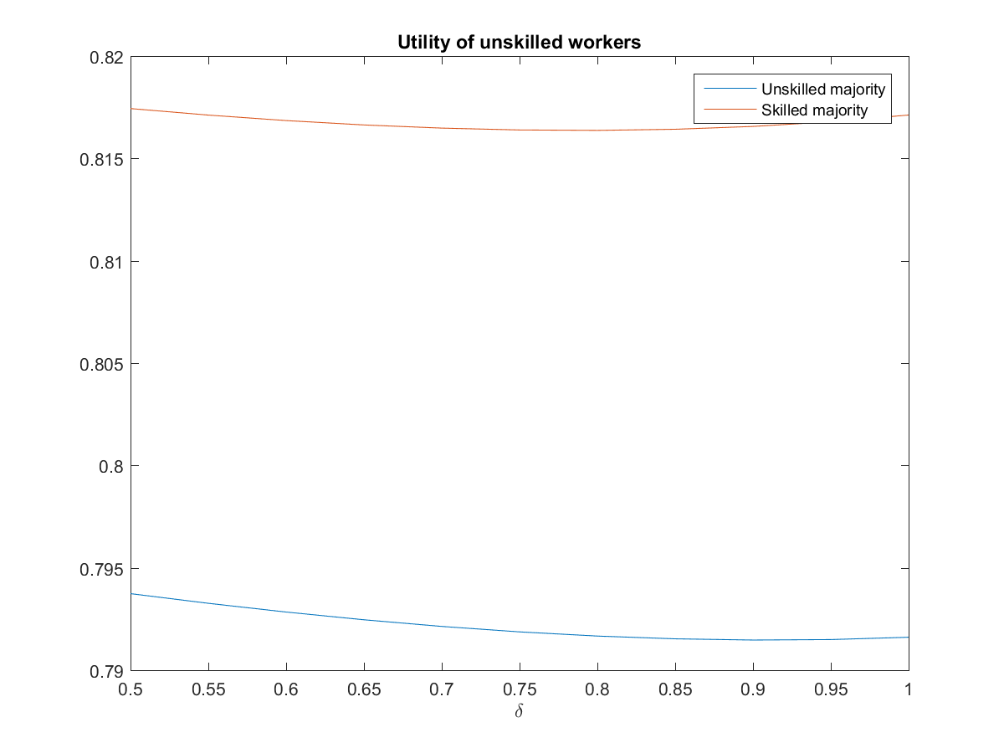
Low-skilled majority
High-skilled majority
Figures 8 and 9 indicate that thanks to the existence of the welfare state tax-transfer policies, financial globalization leads to a Pareto improvement. Both skill types, regardless of who form the majority, benefit from financial globalization. We can also demonstrate that both skill types benefit.

VII. Role of the welfare state
To highlight the role of the welfare state in safeguarding the globalization gains for all (the unskilled-poor individuals and the skilled-rich individuals), we consider in this section the extreme case where the welfare state does not exist (that is, $t_{L}, t_{K }$and b are all set equal to zero).

Figure 10: Financial Globalization without welfare state: utility of the high skill type
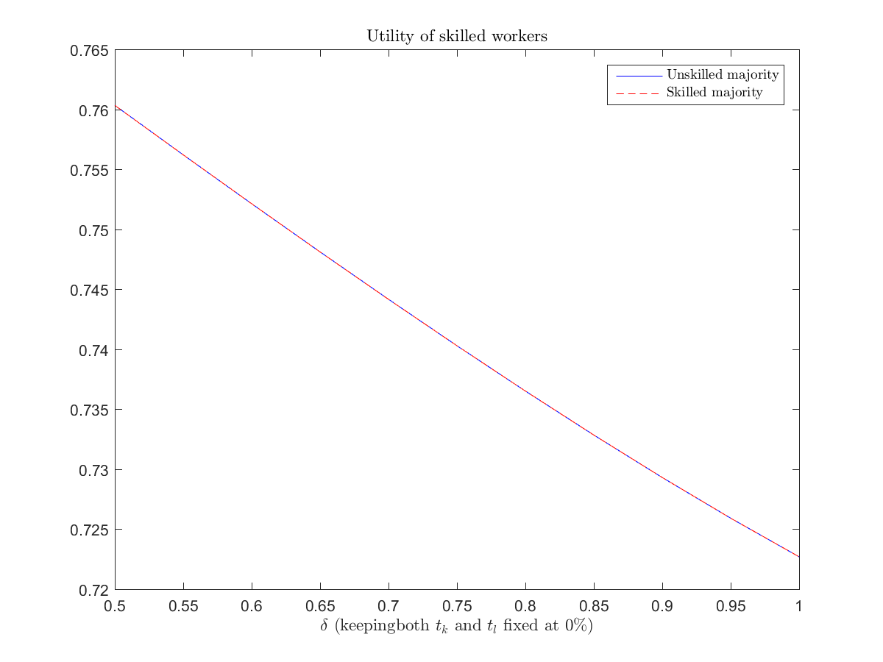
Figure 11: Financial Globalization without welfare state: utility of the low high skill type

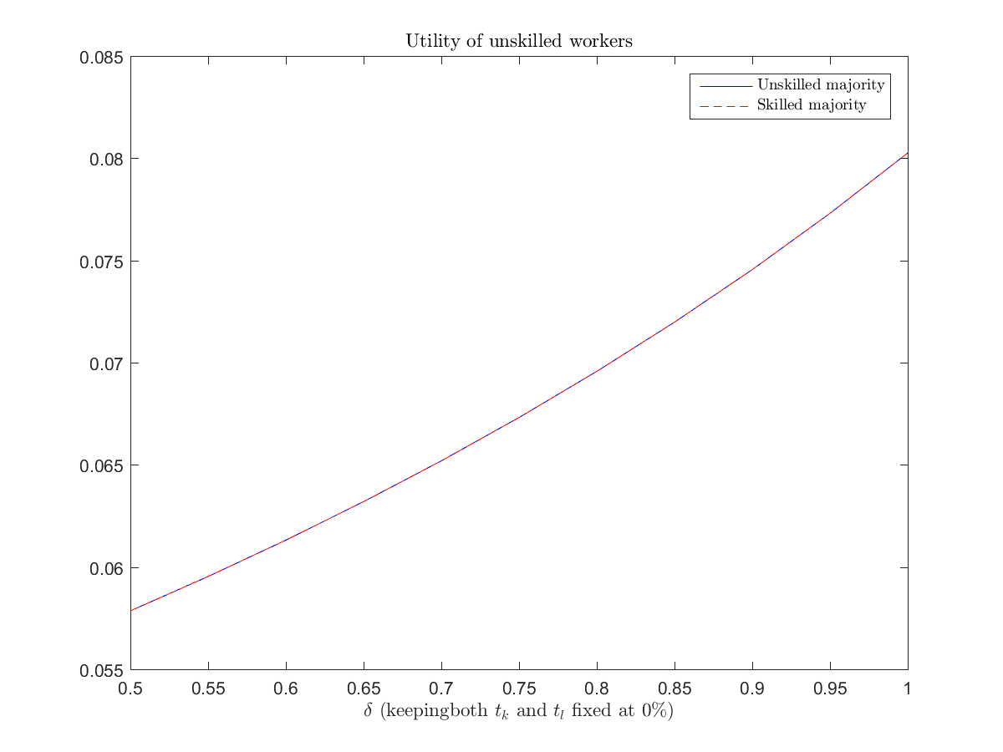

Figure 12: Financial Globalization without welfare state: The Gini coefficient

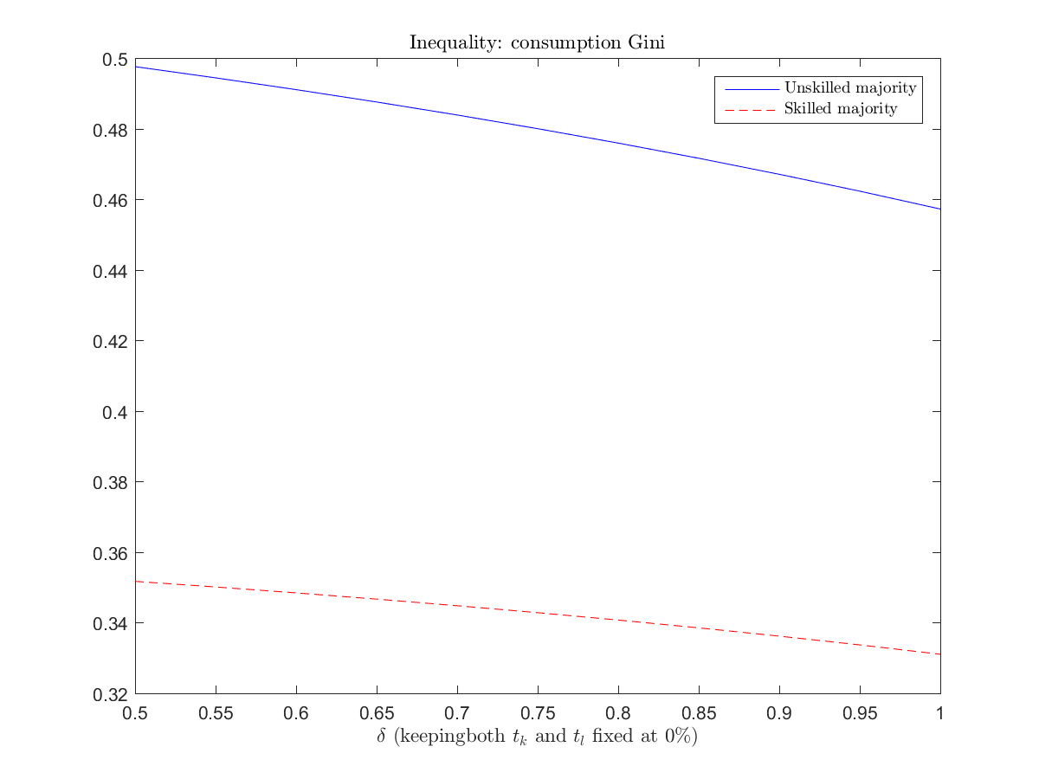

Figures 10-12 demonstrate that without having the welfare state redistribution, the consequences of the financial globalization are that the high skill-rich individual gain, while the low-skill poor lose. Consequently, income inequality worsens. Thus, as shown in the previous section, the welfare state tax and transfer features, although politically controlled by the self-interest majority, are key to guarantee the spread of financial globalization gains to all.

VIII. Conclusion
Capital market globalization affect income distribution in a variety of ways: through its effects on location and sectoral nature of investment and portfolio composition of savings, wages and rents, etc. Furthermore, globalization introduces tax competition among countries, and a possibility of a “race to the bottom”. As a result, the tax burden may shift from the mobile factors (e.g. capital and top-skilled labor) to the weakly mobile factors (e.g. low skill labor). This shift has first-order implications for both the functional and the size distribution of income. A country that imposes high tax rates may push mobile factors (especially capital) abroad where the country cannot effectively tax them, eroding its own tax base and lowering domestic economic activity at the same time. A simple framework to study the issue of tax competition is with the aid of a stylized model with a pure source-based (territorial) taxation. This means that the country does not impose taxes on foreign-source income.
The creation of the single European market is like a “natural experiment” to test the effect of financial globalization on the fiscal underpinnings of the welfare state. It uncovered the phenomenon the race-to-the bottom tax competition which reduces capital income tax revenues. It generated cross-country re-allocation of capital which had first-order effects on income inequality, by chipping away at the domestic tax base. The easing a country access to the world capital markets typically induces also political-economy grounded policy changes that impact income inequality. The downscaled welfare state nevertheless is able to spread the gains from financial globalization among most income groups, regardless of who the decisive voter is determining the tax-transfer policies.
Many large industrialized economies have embarked in recent years on a track of trimming the generosity of their pension and other welfare-state programs. The general rules are quite straightforward: Raise retirement age and curtail benefits. Following the report of the Greenspan Committee (January, 1983), the U.S. has gradually raised the retirement age to reach 67 in the year 2027. Similarly, but much later France, in July 2003 decided to require public sector workers (about one-fourth of the French workforce) to contribute to the state pension system for 40 years, instead of 37.5 years. Also, Germany, which already raised its retirement age from 63 to 65, is currently contemplating raising it further to 67 between 2011 and 2035. With respect to curtailing benefits, this is usually accomplished by abandoning wage-indexation in favor of price-indexation. Naturally, as real wages rise over time (due mostly to productivity increases), price-indexation is less generous to pensioners than wage-indexation; see Cogan and Mitchell (2003) for the U.S. and Thode (2003) for Europe. Financial globalization across various economies is a universal phenomenon to reckon with today. Can the welfare state, financed partly by high capital taxes survive international tax competition brought about by such globalization? Evidently, the answer is in it can; and it seems to be crucial to spread the gains from financial asset trade across various income groups. To demonstrate these points we apply a political economy model where the pillars of the welfare state system are determined by the majority group, poor-low skilled or rich-high skilled to assess the forces of globalization.
We have shown that the social benefits decline as financial globalization increases. What are the gains are for the low-skilled workers that offset the reduction in benefits? It is essentially that they are getting a higher rate of return on their savings due to greater access to world markets. But in essence their well-being is subject to two conflicting forces that are at play: one hand the return to their savings rises with the globalization; on the hand, wages and social benefits fall. If their initial wealth is sufficiently low, and if the low-skilled have preferences that lead them to save much less relative to their wealth than the high-skilled-rich, then the gains-to-all result might not hold. However, even in this case they are better off having a welfare state system in place rather than its absence, to compensate them from depressed wages and declining provision of social benefits.
One would naturally expect that as the share of the elderly in the population rises when the population ages, their political clout would strengthen the pro welfare-state coalition. Similarly, one would expect this coalition to gain more political power as more low-skill migrants are naturalized. Thus, aging and low-skilled migration seem to tilt the political power balance in the direction of boosting the welfare state, imposing a growing burden on the existing workforce. But this political-balance force conflicts with the fiscal-burden force if aging comes together with low-skill migration which increases the share of net recipients of the generous welfare state. But what if the welfare state tries to rely more heavily on capital taxes in order to finance the social benefits it provides? Recall that the old derive most of their income from capital because they retired from work. So, at first thought, it may seem that as the share of the old in an aging population rises, then an attempt to rely more heavily on capital taxes would face a stiffer political resistance. However, after a careful scrutiny of this hypothesis we come to an unconventional conclusion: Aging plausibly tilts the political power balance in favor of larger capital-financed welfare state. Literature cited provides also supportive empirical evidence from the EU for this conclusion. Is the latter conclusion relevant? After all, aging is not the only process witnessed nowadays.

Immigration produces sizeable demographic changes over time that have first-order effect on redistribution policy. Most advanced economies face a generational distribution problem that migration might help with, but migration affects young and old, rich and poor, differently. The welfare state of these advanced economies is also a magnet for migrants, especially the low-skill. On the one hand, the native-born older population need young immigrants to support the welfare state; on the other hand these immigrants may increase the fiscal burden on the native-born young. How these tensions are to be resolved in the political economy context Razin (2018) and Razin and Sadka (2005, 2018).address the impact on income inequality, and redistribution policy as a result of a large wave of skilled immigrants.
Ottaviano and Peri (2012) calculate the effects of immigration on the wages of native US workers of various skill levels in two steps. In the first step they use labor demand functions to estimate the elasticity of substitution across different groups of workers. In the second step, they use the underlying production structure and the estimated elasticities to calculate the total wage effects of immigration in the long run. In the data-preferred model, they find that there is a small but significant degree of imperfect substitutability between natives and immigrants which, when combined with the other estimated elasticities, implies that in the period from 1990 to 2006 immigration had a small effect on the wages of native workers with no high school degree (between 0.6% and +1.7%). It also had a small positive effect on average native wages (+0.6%) and a substantial negative effect (−6.7%) on wages of previous immigrants in the long run.
Appendix

Globalization and income distribution has been studied mostly from the international- trade paradigm perspective. Stolper and Samuelson (1941), early on, explained how increased international trade with capital-intensive good and labor-intensive good, for labor–abundant and capital-abundant countries, should reduce the relative wage in the capital-abundant country; hence, increasing the income gaps between capital and labor. However, Krugman (2008) points that while standard economic analysis predicts that increased U.S. trade with unskilled labor–abundant countries should reduce the relative wages of U.S. unskilled labor, a slew of empirical studies in the 1990s found only a modest effect. Yeaple (2005) demonstrates that a reduction in variable trade costs prompts more firms to adopt the better technology in the differentiated product sector. The most-able workers among those who operate the inferior technology switch employment to firms who operate the more advanced technology, As a result, the least able workers among those who operated the inferior technology switch employment to the traditional sector. Hence, the wage gap between able and less able workers rises. Helpman (2018), however, with a comprehensive review of the literature and evidence, concludes that the aggregative effects of trade-globalization are modest.

References
Auerbach, Alan J. (1983). “Corporate Taxation in the United States." Brookings
Papers on Economic Activity 2: 451-513.
Besley, Tim, Rachel Griffith and Alexander Klemm (2001). “Empirical Evidence

on Fiscal Interdependence in OECD Countries." Institute for Fiscal Studies.

Caminada, Koen, Kees Goudswaard, and Olaf Van Vliet, (2010), “Patterns of Welfare State
Indicators in the EU: Is there Convergence?” Journal of Common Market Studies, Volume

48, Issue 3, , June 2010, Pages 529-556.

Devereux, Michael P., and Rachel Griffith (2002). “The Impact of Corporate

Taxation on the Location of Capital: A Review." Swedish Economic Policy

Review.
Devereux, Michael P., and Rachel Griffith, and Alexander Klemm (2002), “ Corporate income tax reforms and international tax competition,” Economic Policy, Volume 17, Issue 35, 1 October 2002, Pages 449–495.

Gordon, Roger (1986), Taxation of Investment and Savings in a World Economy,” American Economic Review.
Hall, Robert E. and Dale W. Jorgenseon (1967). “Tax Policy and Investment
Behavior." American Economic Review 57: 391-414.
Helpman, Elhanan (2018), Globalization and Inequality, Harvard University Press.
Hines, James R. (1999). “Lessons from Behavioral Responses to International

Taxation." National Tax Journal 52: 304-322.
Hines, James, and Lawrence Summers (2005), “How Globalization Affects Tax Design,” NBER working paper 14669.
Ottaviano, Gianmarco, I.P., and Giovanni Peri (2012), "Rethinking the Effect of Immigration on Wages,"

Journal of the European Economic Association, Volume 10, Issue 1, 1 February 2012, Pages 152–197.

King, Mervyn A., and Don Fullerton (1984) “Comparisons of Effective Tax Rates,” in King, Mervyn A., and Don Fullerton (eds.) The Taxation of Income from Capital: A Comparative Study of the United States, the United Kingdom, Sweden, and Germany, University of Chicago Press.
Krautheim, Sebastian, and Tim Schmidt-Eisenhor (2011), “Heterogeneous firms, ‘profit

shifting’ FDI and international tax competition,” Journal of Public Economics

Volume 95, Issues 1–2, February, Pages 122-133.

Krugman, Paul (2008), “Trade and Wages, Reconsidered,” Brookings Papers on

Economic Activity Spring 2008, pp. 103-154.

Krussel, Per, Jose-Victor Rios-Rull, andGiovanni L. Violante (2000), “Capital-Skill Complentarity and Inequality: A Macroeconomic Analysis,” Econometrica, 68, pp. 1029-33.
Lassen, David D. and Peter Birch Sorensen (2002). “Fnancing the NordicWelfare

States: The Challenge of Globalization to Taxation in Nordic Countries."

A Report prepared for the Nordic Council of Ministers, June.
Razin, Assaf (2018a), Israel and the World Economy: The Power of Globalization, MIT Press.

Razin, Assaf (2018b), “Israel’s immigration story: Winners and Losers,” Israel Economic Review Vol. 15, No. 1 (2018), 73-106
Meltzer, Alan, H, and S F Richard (1981), “A Rational Theory of the Size of Government”, Journal of Political Economy, 89 (5), 914–927.

Razin, Assaf and Efraim Sadka (1991), “International Tax Competition and Tax Harmonization,” Economics Letters.
Razin, Assaf, and Efraim Sadka (2014), Migration States and Welfare States: Why is America
Different from Europe? Pelgrave Pivot Series, Pelgrave-MacMillan.
Razin, Assaf and Efraim Sadka (2017), “International Tax Reforms with Flexible Prices,” CEPR Vox.
Razin, Assaf, and Efraim Sadka (2018), “Migration-Induced Redistribution with and without Migrants’ Voting,” FinanzArchiv / Public Finance Analysis (FA) Volume 74, Number 1, March, special issue in honour of Hans Werner Sinn, pp. 158-172.

Razin, Assaf, Efraim Sadka, and Chang Woon Nam (2005), The Decline of the Welfare State: Demography and Globalization, MIT Press.
Razin, Assaf and Efraim Sadka (2017) “International tax reforms with flexible prices,” CEPR EU-Vox,

18 December 2017.

Sorensen, Peter Birch (2002). “The Case for International Tax Coordination

Reconsidered." Economic Policy 31: 429-472.

Razin, Assaf, Efraim Sadka, and Phillip Swagel (2002a), “The Aging Population and the Size of the Welfare State”, Journal of Political Economy,110, pp.910-918.

Razin, Assaf, Efraim Sadka, and Phillip Swagel (2002b), “Tax burden and migration: a
political economy theory and evidence”, Journal of Public Economics, 85 (2), 167–
190.
Stolper, Wolfgang W., and Paul A. Samuelson (1941), ”Protection and Real Wages,”
Review of Economic Studies, 9, pp. 58-73.
Swank, Duane and Hans-George Betz (2003), “Globalization, the welfare state and right-wing populism in Western Europe,” Socio-Economic Review, 1, 215-255.

Yeaple, Stephen R. (2005), “A Simple Model of Firm Heterogeneity and International Trade,

and Wages.” Journal of International Economics 65: 1–20.

UNCTAD (2018), Country Fact Sheets 2018,
http://unctad.org/sections/dite_dir/docs/wir2018/wir18_fs_cn_en.pdf

We thank Elhanan Helpman, for insightful discussion, and to Alexander Schwemmer for competent research assistance.
Globalization has a new face. China’s emergence as a great economic power has induced a significant shift in the patterns of world trade, with major effects on income inequality in its trade partners. Alongside the consumer benefits of expanded trade there are substantial adjustment costs and distributional consequences for them. Import competition from China, which surged after 2000, was a major force behind both reductions in US manufacturing employment and—through input-output linkages and other general equilibrium channels—weak overall job growth. However that import competition from China did not have large aggregative effects in the United States, but it had substantially different employment repercussions in different commuting zones. The relative reductions of employment were regionally concentrated. The US rise in wage inequality that is, the rise of the college wage premium, is only partly the result of trade globalization; more important factors are technological progress (biased towards skilled labor) and the decline of the power of labor unions that were behind strong industrial wages. China is also a key player in world finance, impacting on all other open capital-market economies. Indeed, several indicators point to a strengthening of China's role as an investor country in recent years. By 2017 China is one of the most important FDI source, and destination, among the economically more advanced economies, such as the US, EU, Hong Kong, South Korea, Taiwan and Singapore. Chinese inward FDI as percentage of GDP has been: 13.7 in 2014, 10.9 in 2015, 12.1 in 2016, and 12.6 in 2017. Chinese outward FDI as percentage of GDP has been: 2.4 in 2014, 9.8 in 2015, 12.1 in 2016, and 12.6 in 2017.
Recall that by the Fisher equation: $1+r_{t}^{US}=\left(1+i_{US}^{t}\right)\frac{P_{US,t}}{P_{US,t+1}}$ , That is, $(1+r_{t}^{i})\frac{q_{i/{US}, t+1}}{q_{i/{US}, t}}=\left(1+i_{i}^{t}\right)\frac{P_{i,t}}{P_{i,t+1}}\frac{q_{i/{US}, t+1}}{q_{i/{US}, t}}$ .
Corporate Rate fell from 35 to 21. Some domestic investment qualified for an immediate deduction as an expense. Multinational corporations faced a substantially modified treatment of their activities– in the direction of facilitating the repatriation of foreign profits; Changing US Tax Business tax system to source-based (territorial).
The 2017 large tax cut, mainly aimed at corporations and business owners. The real logic behind corporate tax cuts is that they’re supposed to lead to higher investment. This investment, in turn, would gradually increase the stock of capital, simultaneously driving down the pretax rate of return on investment and pushing up wages, thanks to a long -term increase in domestic investment, mainly financed by inflows of capital from abroad. The pre-reform US tax system was based on worldwide (residence-based) taxation, under which income was taxed at an equal rate regardless of where profits were earned. Since repatriation of foreign profits triggered high US taxation, US multinationals had an incentive to refrain from bringing home their foreign earnings. In the light of substantial amounts of “trapped earnings” abroad, tax holidays became a strategic tax planning tool of US multinationals. Along with the transition to a territorial international tax system, the reform further provides for a one-time deemed repatriation tax of deferred foreign corporate profits at a rate of 15.5% (cash assets) and 8% (illiquid assets).
Michael Devereux, Rachel Griffith and Alexander Klemm (2002) analyze the development of taxes on corporate income in EU and G7 countries over the 1980s and the 1990sthey establish that tax revenues on profitable investments had fallen. In particular, taxes on income earned by multinational firms are subject to tax competition forces. Additional evidence pertaining to international tax competition for relatively mobile portfolio investments, so that a country with more mobility has lower capital tax rates, is abundant. See empirical support for the hypothesis in Hines (1999), Sorensen (2002), Besley, Griffith and Klemm (2001), Devereux and Griffith (2002), and Lassen and Sorensen (2002), Razin, Sadka, and Nam (2004), and Krautheim and Schmidt-Eisenhor (2011).
Calculations based on the well-known work of Hall and Jorgenson (1967), who introduced the user cost of capital approach; applied to international data by King and Fullerton (1984). Figure 1 follows the formula for the effective tax rate on corporate income ($τ_{e}$), as refined by Auerbach (1983): $$τ_{e}=\frac{\left(r+δ\right)\left(1-τ_{s}z\right)-(r+δ)(1-τ_{s})}{\left(r+δ\right)\left(1-τ_{s}z\right)-δ(1-τ_{s})}$$ where  − Real cost of funds (real rate of return the firm must earn after corporate taxes by the instruction of its shareholders). $δ$ − physical rate of depreciation (assumed exponential) $τ_{s}$− statutory corporate tax rate  − Present value of depreciation allowances.
They linearly regress the annual growth rate of several social protection indicators on the initial level of the social protection indicator at the beginning of the period. The coefficient for absolute β‐convergence is estimated using an ordinary least square regression model of cross‐sectional data. If the coefficient β is negative (positive), we say that there is absolute convergence (divergence) in social protection levels across countries. The higher the value of β, the faster the social protection indicator in the poor region converges toward the level of the rich one. The hypothesis to test is that coefficient β is negative.
Under the source (territorial) principle of international taxation only income from domestic sources are subject to a tax, whereas foreign-source income is exempt. Under the residence principle, in contrast, income is taxed on a world-wide basis. Razin and Sadka (2017) illustrate diagrammatically the efficiency dis-advantage of the equilibrium under the source principle, compared to the residence equilibrium. Because the consumption possibilities frontier shrinks under the source principle, relative to the frontier under the residence principle, the latter is more efficient. However, tax revenue collection is larger under the former, because of the existence of tax havens and lack of sufficient international tax coordination.
Evidently, debt flows have a special tax treatment deserve a rigorous separate analysis; they will not be considered here.
The parameter $δ$ captures (albeit in a mechanic way) a group of frictions, contractual and informational. Such frictions, which affect the volume and the composition and the volatility of international capital flows, cause deviations from the “law of one price”. As an example, foreign direct investors get more efficient outcomes than foreign portfolio investors because the former have more direct control over management. Thus, they are able to make a better-informed decision of how to run the business. However, the better information mires FDI investors with the “lemons” problem: If the investors’ liquidity dries up, forcing the investors to sell off foreign subsidiaries, market participants would not know whether the subsidiary is liquidated because of the investors’ liquidity problems or because of bad inside information about the profitability of the subsidiary. Consequently, the market will place a discount on assets sold by an FDI investor, who has the inside information, unlike the FPI investor.
Note that marginal changes in the amount of capital which leaves the domestic economy could be positive or negative. Consequently these changes have negative or positive effects on the capital income tax base.
We have done various simulations with different specification: (1) social benefit and private consumption are perfect substitutes; (2) The social benefit sub-utility enters the utility function multiplicatively. However, qualitative results are similar for a variety of these specifications.
Note that $δ, r^{* },$ and $t_{K}^{*}$ are indistinguishable as the relevant economic parameter is $1+\left(1-t_{K}^{*}\right)r^{*}-δ.$
Although in the absence of uncertainty and information and contractual frictions the model equilibrium configurations is either exclusive capital exports or exclusive capital imports, with frictions equilibrium may include capital exports of assets and capital imports of other assets, all at the same time. Indeed, U.S. is both equity capital exporter and debt capital importer.
Note that we assume perfect substitution between the two labor skill types and complementarity between capital and labor. If there is complementarity- relation between all factors of production, our result is still valid. Krusell et al (2000), who analyzed US data, decompose capital into equipment and structures. They were able to track wage gap for the years 1960 to 1990 and show that capital accumulation explains most of the rise in wage inequality. Note, however that capital which leaves the domestic economy as a result of financial globalization (and escape tax under the source-territorial tax principle domestic taxes), with input-substitutability between low-skilled labor and capital, tends to raise low-skilled wages and raise the domestic return to capital that they own.
As utility is ordinal, we cannot just compare whose utility rises by more. Instead, we calculate a sort of consumption equivalent to the utility. Specifically, we ask what a uniform percentage increase in both present and future consumption generates the same increase in ordinal utility as generated by the financial globalization (the change in $δ$). Formally, denote this percentage increase by $x_{i}\left(δ\right), i = l, h$. Define consumption equivalent utility by $[({\overline{c}}_{1i}{)(1+ x_{i}\left(δ\right))]}^{β}[({\overline{c}}_{2i}{)(1+ x_{i}\left(δ\right))]}^{1-β}+ {\overline{b}}^{σ}= {\left({\tilde{c}}_{1i}\right)}^{β}{\left({\tilde{c}}_{2i}\right)}^{1-β }+ {\tilde{b}}^{σ}$, where “-“refers to the pre-change in $δ$ , and “$\sim$” refers to the post- change in $δ$. i = l, h. This yields:$1+ x_{i}\left(δ\right)= \frac{\tilde{u}-{\overline{b}}^{σ}}{\overline{u}-{\overline{b}}^{σ}}$.
International tax competition and border tax adjustments of income tax have received increasing public and scholarly attention since the introduction of the US 2017 US Tax Bill, which shifts corporate taxation to the source (territorial) principle.
Swank and Betz (2003) find that net of the impacts of other political forces, the universal welfare state, as measured by an index of coverage, generosity and active labor market programs, significantly depresses the votes of the populistic new political right. Its political clout has increased in Europe by globalization forces (especially volume of refugees and asylum seekers.
Ottaviano and Peri (2012) emphasize that a production function framework is needed to combine own-group effects with cross-group effects in order to obtain the total wage effects for each native group. In order to obtain a parsimonious representation of elasticities that can be estimated with available data, Authors adopt alternative nested-CES models and let the data select the preferred specification. New to this paper is the estimate of the substitutability between natives and immigrants of similar education and experience levels.

